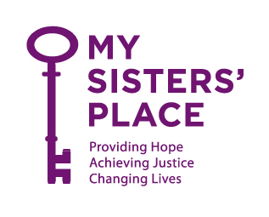

March 21, 2020

To Whom It May Concern:

This letter is to inform you that _________________________ is an employee at My Sisters’ Place, Inc., a non-profit organization that serves victims of domestic violence and human trafficking. Pursuant to New York State Governor Andrew Cuomo’s Executive Order 202.6, known as “New York on PAUSE” and in response to the current COVID-19 health crisis, employees of domestic violence organizations are considered “essential employees” who must be able to report to work. Specifically, our organization falls under the “Providers of Basic Necessities to Economically Disadvantaged Populations,” which includes “those operating community shelters and other critical human services agencies providing direct care or support.” As such, this employee is authorized to travel to and from work at this time and at all times to perform these essential functions.

If you have any questions or concerns, please contact my Chief Program Officer, Amy Siniscalchi, at XXXX.

Thank you, and be safe.

Karen Cheeks-Lomax, Esq.
Chief Executive Officer

